

Lung Cancer Dataset – Data Exploration & Preprocessing
Presented to
Faculty Dean: Dr . Mohamed Talaat.
Dr: Rasha Saleh
TA: Mohamed Tarek

Participants
Hosny Hassan Hosny 192200372
Hesham Mansour 191900312

1. Introduction
In the context of data mining, the initial phase of data exploration and preprocessing plays a vital role in ensuring the reliability and effectiveness of subsequent analysis and modeling. This report documents the first stage of a comprehensive data mining project focused on a publicly available lung cancer dataset. The primary objective at this stage is to thoroughly understand the structure and content of the dataset, identify and address data quality issues such as missing values and outliers, and apply appropriate preprocessing techniques. These foundational steps are essential to prepare the dataset for more advanced data mining tasks and to facilitate the extraction of meaningful insights.
This project focuses on the **exploration and preprocessing** of the [Lung Cancer Dataset](https://www.kaggle.com/datasets/khwaishsaxena/lung-cancer-dataset). It is part of a final project task that includes cleaning, transforming, and preparing the dataset for future machine learning use.

2. Dataset Overview
The dataset consists of medical data related to patients who may have lung cancer. Each instance in the dataset represents a patient, with various features representing health indicators and risk factors.
Features Include:
- GENDER (Male/Female)
- AGE
- SMOKING
- YELLOW_FINGERS
- ANXIETY
- PEER_PRESSURE
- CHRONIC DISEASE
- FATIGUE
- ALLERGY
- WHEEZING
- ALCOHOL CONSUMING
- COUGHING
- SHORTNESS OF BREATH
- SWALLOWING DIFFICULTY
- CHEST PAIN
- LUNG_CANCER (Target: Yes/No)

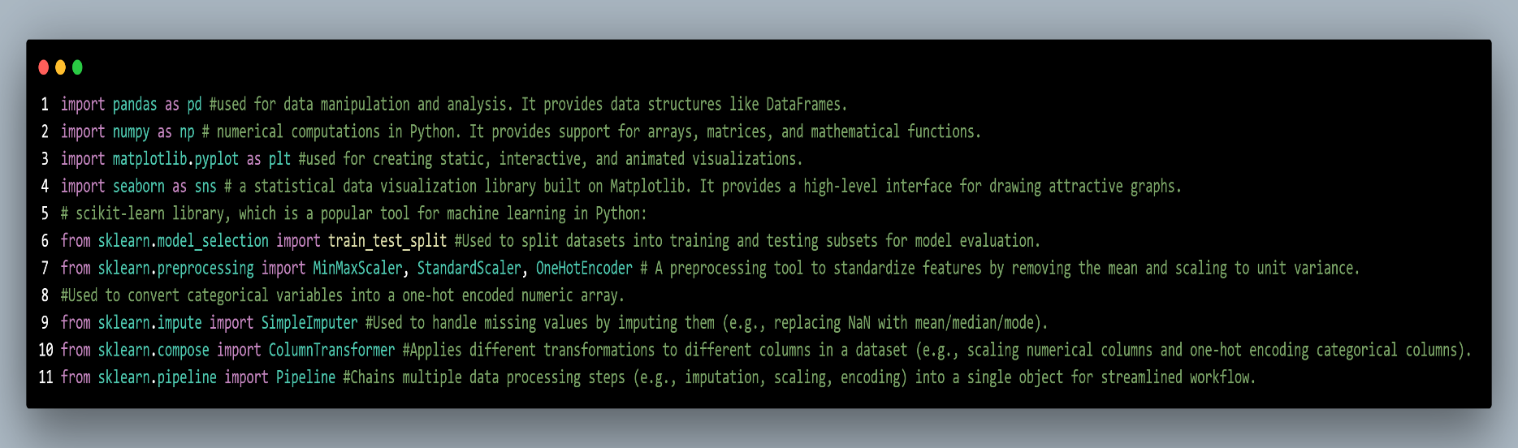
1.Libraries and Tools Used:

2. Load the dataset:
- Dataset loaded using `pandas.read_csv()`
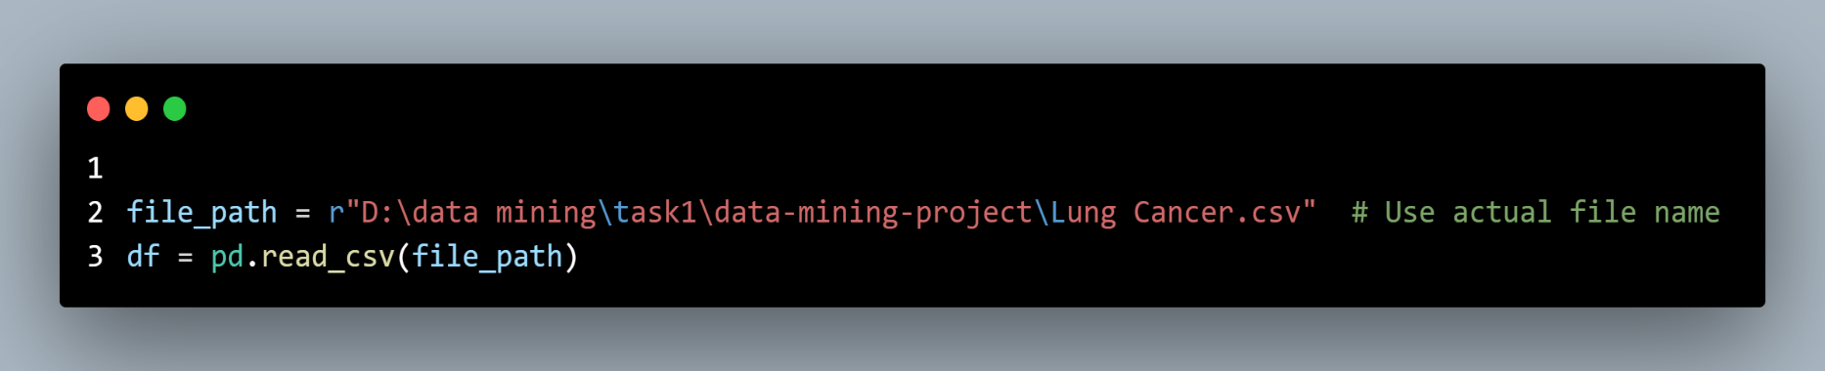
- Handled missing values by detecting `?` as `NaN`

3. Explore the dataset’s features and target variable
- Displayed first 5 rows
- Inspected datatypes and value distributions
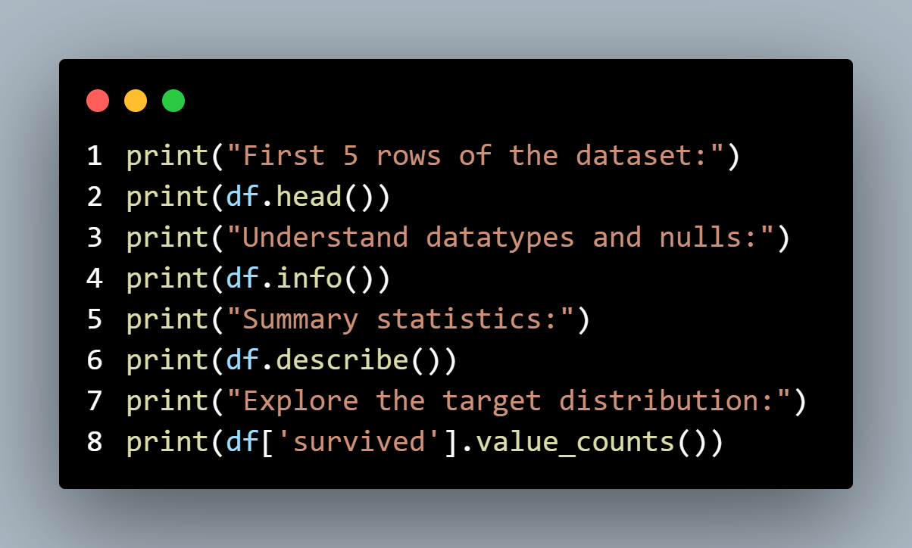
- Examined missing values per column

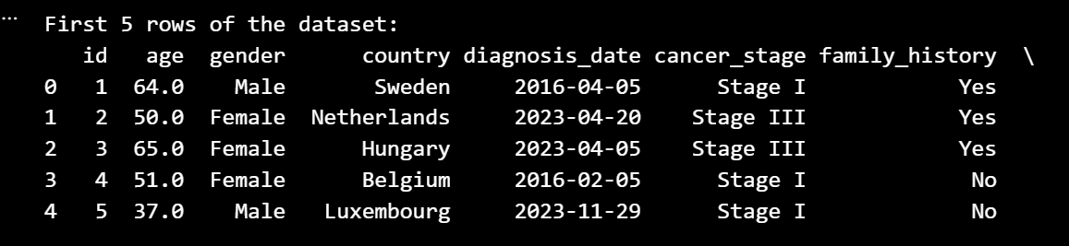
Output :

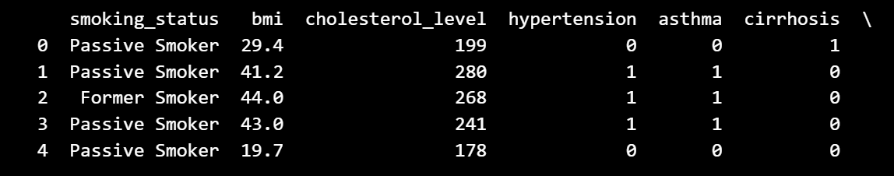
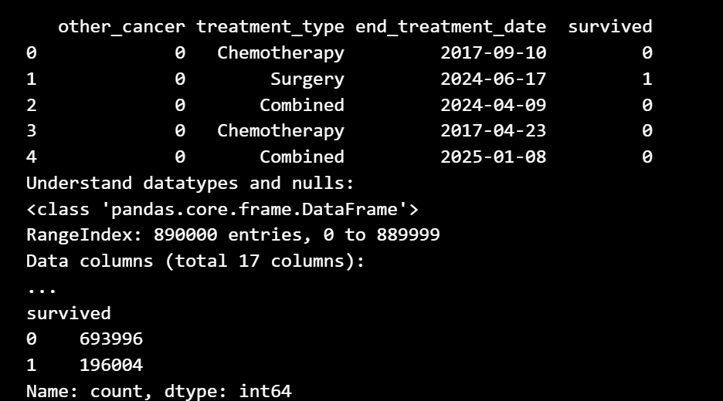

4. Handle missing values and outliers
- Identified and filled missing values using:
- **Median** for numeric features
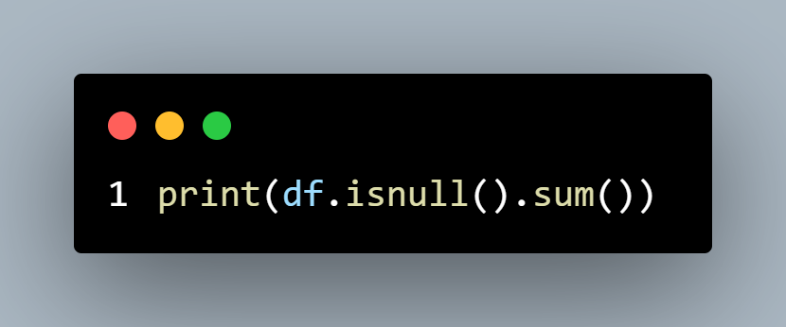
- **Mode** for categorical features (optional)

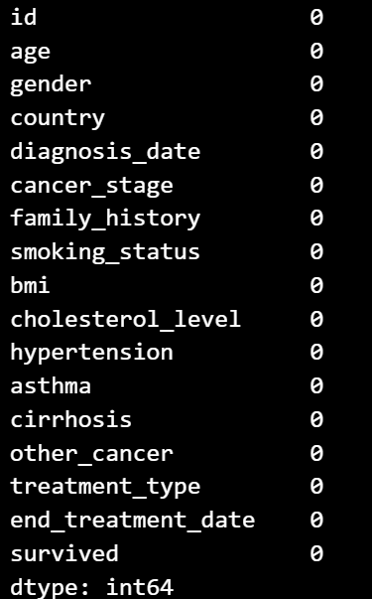
Output :

5. Outlier Detection and Handling:
- Used the **IQR method** to detect outliers in numeric columns
- Applied two methods:
- **Removal** of rows containing outliers
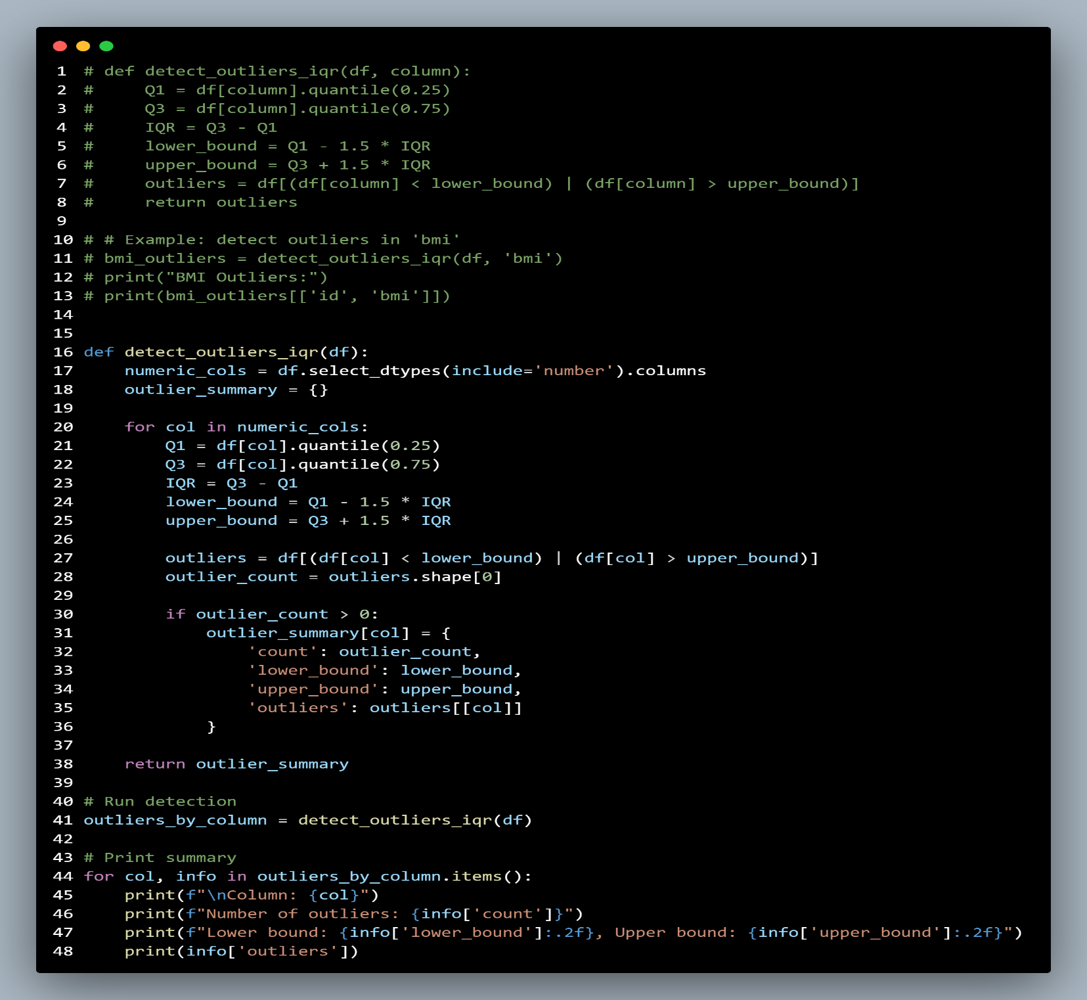
- **Capping (Winsorization)** to clip outlier values to valid range.
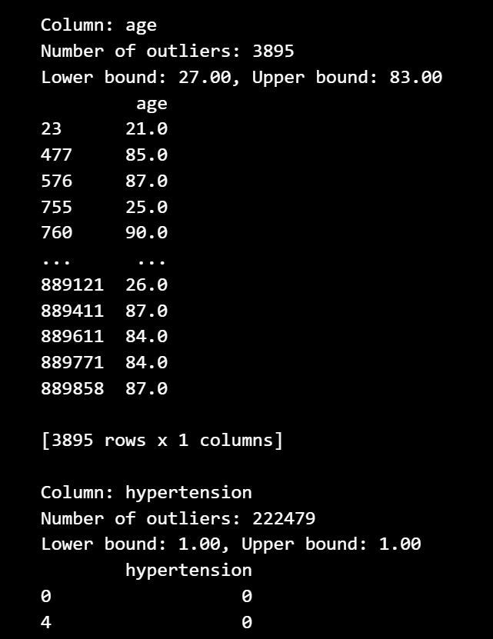
Output:



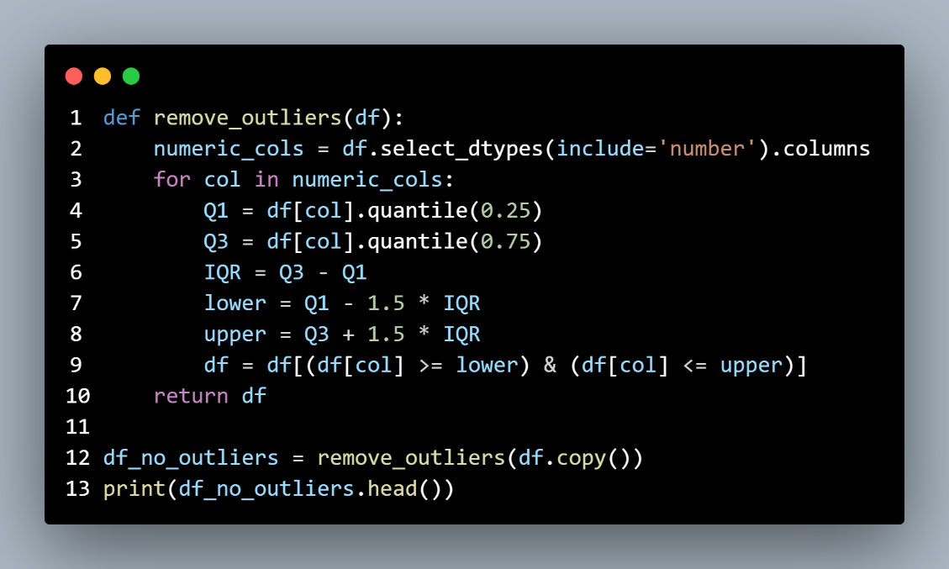
Remove Outliers:

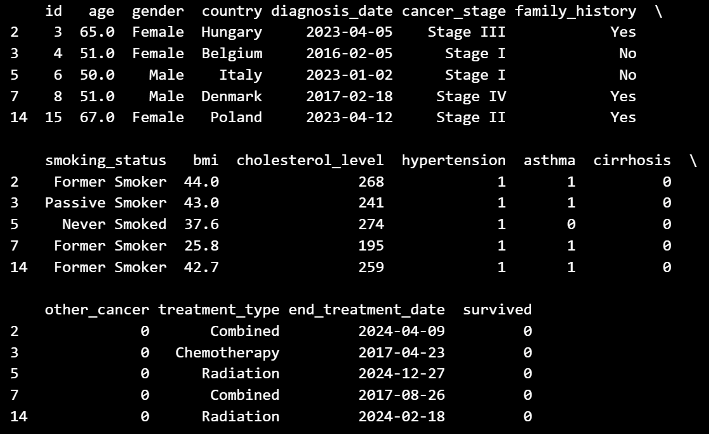
output:
6. Perform feature scaling or normalization
- Applied **Min-Max Normalization** to scale numeric features between 0 and 1 using `MinMaxScaler`
- Standardization using `StandardScaler` is supported (not the default)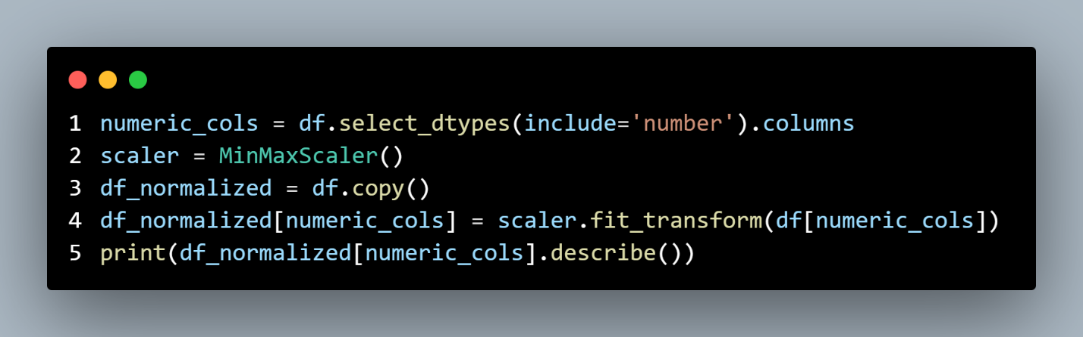
Output :
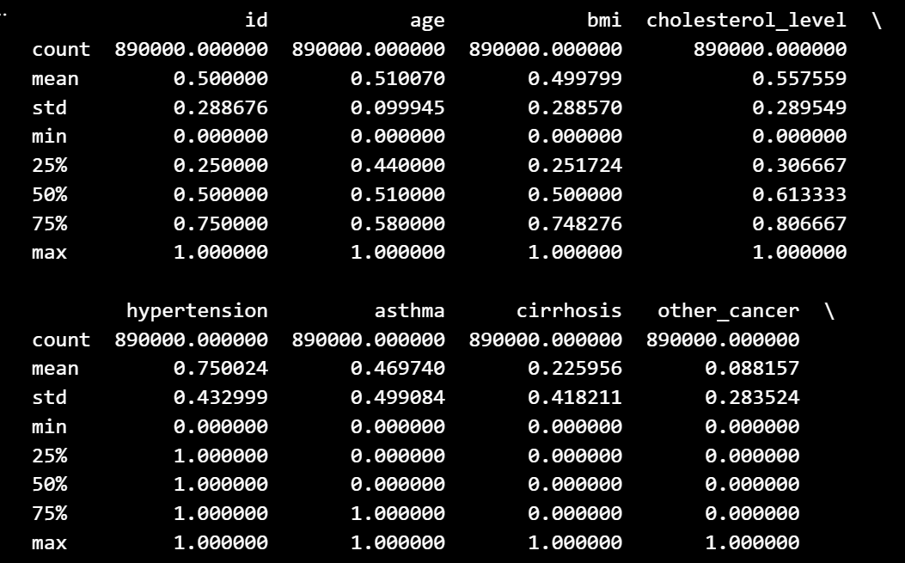

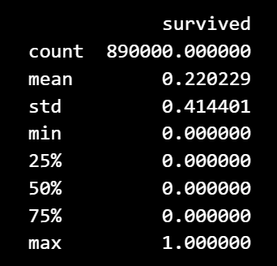
7. Split the dataset into training and testing sets:
- Separated data into **features (`X`)** and **target (`y`)**
- Encoded categorical variables using `pd.get_dummies()`
- Split into training and testing sets using `train_test_split()` with `stratify=y` for balanced classes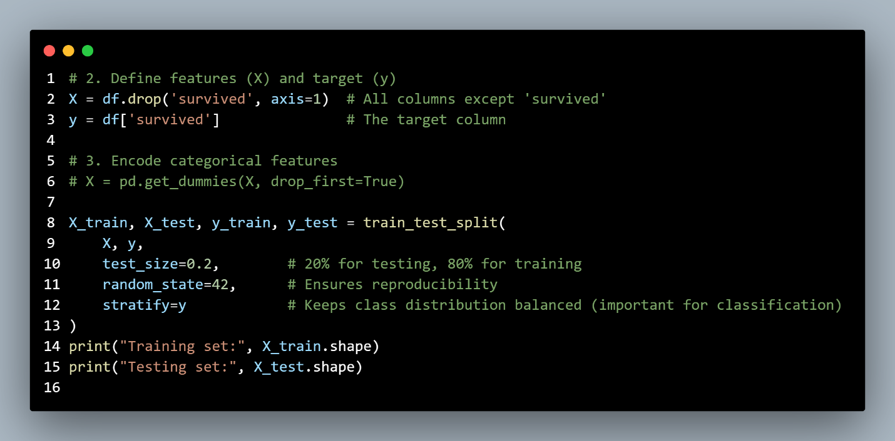
Output :
Training set: (712000, 16)
Testing set: (178000, 16)
8. Feature Engineering:
- Created a new column: `treatment_duration_days` by calculating:
```
treatment_end_date - diagnosis_date
```
- Visualized this feature using a **boxplot** to analyze its spread and detect any anomalies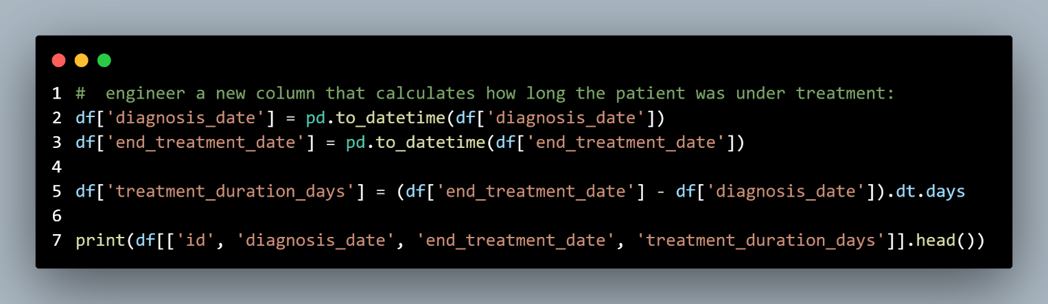
Output:
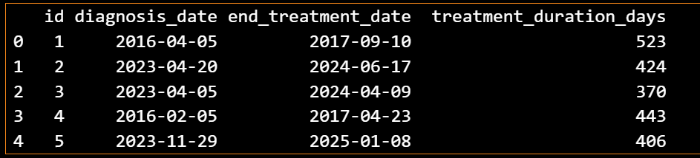

9.Visualizations:
- Boxplot of `treatment_duration_days` to analyze distribution
- (Optional) Histogram and additional plots can be added for deeper insights
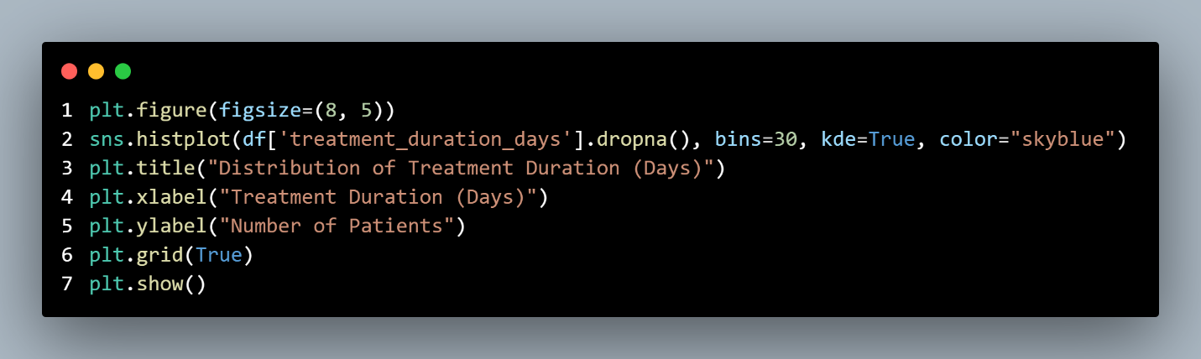
Output:
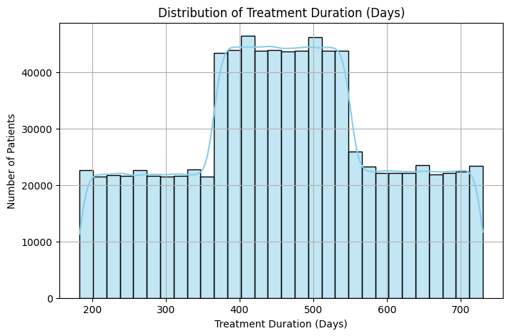

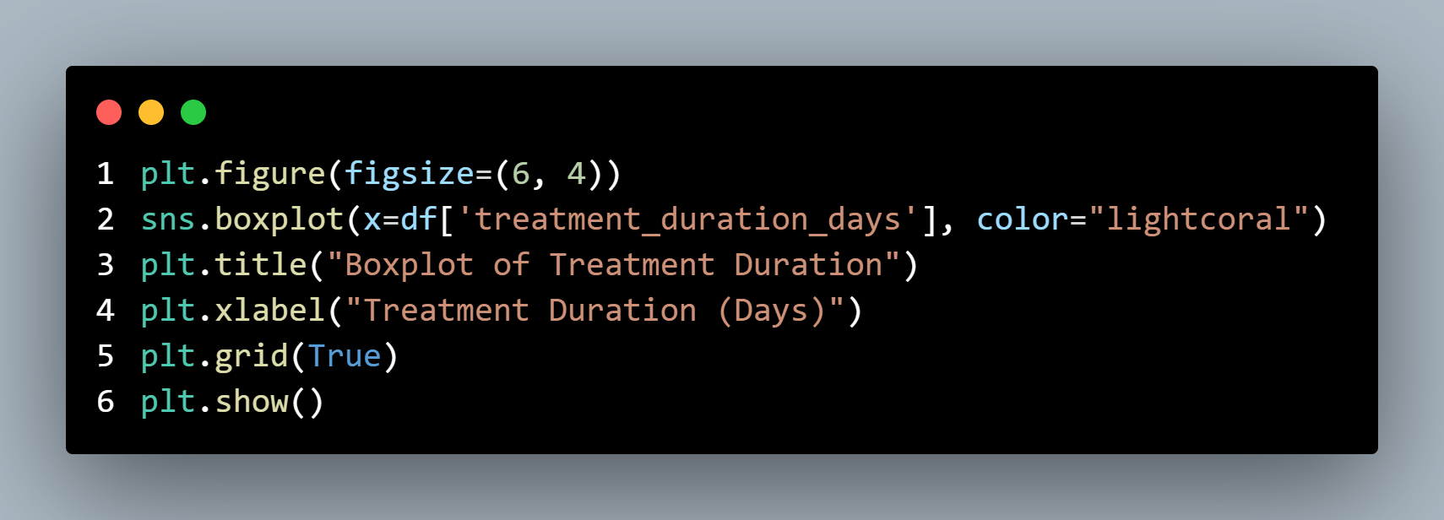
Output:
